DIS-POINTS-Turkey Tail

Turkey-tail Cluster

The Turkey Tail point was described under the name Fulton Turkey Tail by E. Scully (Scully, 1951, p. 11) and is now known as four sub-types Harrison, Hebron Fulton and Fulton stemmed, of which the current specimen is an example. The Fulton/Dickson variety Turkey-tail exhibits an expanding stem with a straight to convex basal edge. This variety of Turkey-tail lacks obvious shoulders. The excurvate contour of the blade edge expands from the tip to an approximate midpoint on the blade, then constricts to join the stem without interference from shoulders. The resulting form is lenticular and nearly elliptoid, with the small short stem protruding beyond this basic shape.

**FULTON STEMMED** The Fulton stemmed haft morphology is divided into two parts. This variety exhibits the basal form of the Fulton type below a straight stemmed extension. Blade characteristics are basically similar to other Turkey tails except that well defined shoulders are exhibited. These can either be weak and sloping or robust and squared. A sub-variety of this haft characteristic is a segmented form which exhibits a full, straight-sided dual segment with a straight or slightly convex base as in this specimen.

***Age and Cultural Affiliation***Turkey-tails are diagnostic of the Late Archaic-Early Woodland transitional period. Culturally, Turkey-tails relate to what has been named the Red Ocher complex (Cole and Deuel 1937), known primarily from funerary contexts in the Illinois Valley and Midwest generally. These have also been found in Meadowood phase contexts in New York (Ritchie 1969a: 181-183)' Associated materials include Pomranky (Faulkner 1960b) and Red Ocher type points (Scully 1951:9; Perino 1968a: 72), copper, marine shell, and other artifacts (Ritzenthaler and Quimby 1962; Binford 1963a). In addition, Conrad (1981 :185, Plate 35b) has named another associated form, the Merkle Side Barbed. Turkey-tail points have also been associated with Adena points and Early Woodland ceramics (Schock and Dowell 1981). Didier (1967: 10) places Turkey-tails within a time period beginning about 1500 B.C. and lasting until about 500 B.C., where they overlap morphologically with the Adena Ovate-base style (Adena Stemmed). Some dated sites with reported Turkey-tail associations are provided below. Those with dates later than 500 B.C. are associated with material which overlaps the Adena Ovate-base style.

***Distribution:***

Turkey-tail distribution covers much of the Great Lakes and Midwest regions on into New York state, southern Ontario, and Connecticut (Lavin 1984). Refer to Didier (1967) for a detailed attempt to construct regional distributions of the various types. Turkey-tails occur in low frequency as far south as Tennessee (Smith and Hodges 1968: 109). A biface type somewhat similar to the Turkey-tail is present at the Spiro site (Caddoan Mississippian) in Oklahoma. Nonetheless, any connection has been discredited (Brown 1976: 131), and the western extent is probably confined to eastern Missouri, Iowa, and Wisconsin in the Mississippi Valley. The vast majority of Turkey-tails were manufactured in the localized raw material source areas of southern Indiana (primarily ; Harrison County), southern Illinois, and northern Kentucky (Stemle 1981 :115-116). .The Harrison County chert source has recently been studied in Harrison and Crawford Counties, Indiana (Bassett 1981; Justice 1981a; Munson and Munsbn 1981). The bedrock units have been identified in the Fredonia Member of the St. Genevieve Limestone (Bassett 1981). The chert occurs as a unit named the Wyandotte chert zone containing oolitic and non-oolitic nodular Location of find: Harrison County, Indiana. This Turkey Tail point is made from a dark grey Wyandotte chert derived from quarries in southern Indiana where it was found.

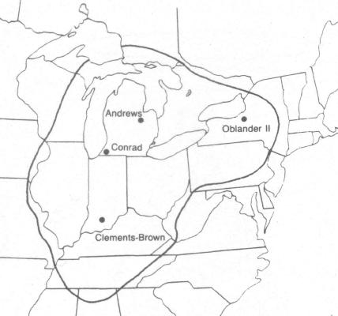

Fig. 1Map of Turkey-tail Cluster Aerial Distribution and Important Sites

Turkey-tail Cluster Important Sites:

Michigan, Andrews Site: 1220 B.C. +/-300 (Crane and Griffin 1960: 34; Fitting 1970: 84).

New York, Oblander II Site: 998 B.C. +/- 170 (Libby 1952:77).

Kentucky 15 Wa 981 Site: 160 B.C. +/- 105 (Schock and Dowell 1981: 1). 495 B.C. +/-90; 535 B.C. +/-70 (Schock and Langford 1981 :46). 15 Si 7